Portfolio Website Documentation:

Prerequisites:

1. Node – Node is used in order to download packages or manage dependencies
2. Vite – Used for establishing the react environment

Installations:

1. Vite

* npm create vite@latest – Creates a directory for the React Project.

Framework: React

Variant: TypeScript

1. React

* npm install – Installs the core libraries needed by the React
* npm install react-router-dom – Installed in order to use the routing capabilities of the react environment. To verify the installation, the ‘**react-router-dom**’ should be in the dependencies of ‘package.json’ file

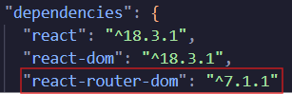

1. Tailwind

* npm install -D tailwindcss – Modifies the ‘devDependencies’ section in the ‘package.json’ file in order to install the tailwindcss as a development dependency

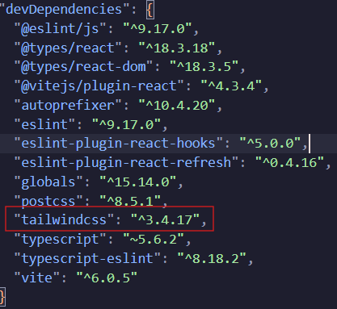

* npx tailwindcss init – Creates a default configuration file for the tailwindcss.



Configurations:

1. **postcss.config.ts** – There was an error in installing the ‘postcss.config.ts’ file, therefore I had to create one manually. The file is used to configure the postcss for typescript variant of react. The content of the whole file should look like this:

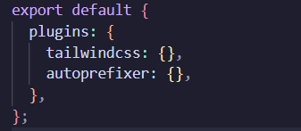

Routing:

The main.tsx is in-charge of the routing for all the webpages. The code snippet below indicates the necessities and dependencies imported to take effect for the whole website

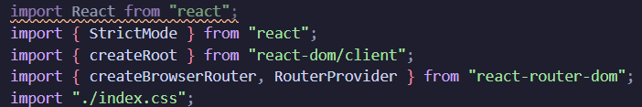

And the code snippet shown are the paths to the webpages given a variable name for a better practice.

